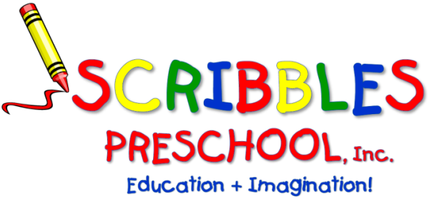

SCRIBBLES-N-BITS
Bring your “little bit” and enjoy time socializing and playing together. These informal sessions encourage friendship, fun, and exploration. You and your child will be participating in a variety of age appropriate, stimulating activities. Parenting issues and concerns are shared and discussed.

Songs/stories/finger plays/musical instruments, parachutes,
fine and gross motor activities and more!

FOR: 1–2-year-olds with adult

WHERE: Scribbles Preschool – Zebra Room

DATES: Oct. 7th,14th, 21st ,28th, Nov. 4th, 11th,18th, (no class on Nov. 25th) Dec. 2nd,9th,16th
Jan. 6th, 13th, 20th, 27th)

TIME: 9am to 10am

FEE: * $224.00 (Make check payable to Scribbles Preschool, Inc.)

* Any days you cannot attend, please indicate the days and deduct $16 per day.

STAFF: Meredith Giudice

Please keep top section & return the registration below prior to attendance.
- - - - - - - - - - - - - - - - - - - - - - - - - - - - - - - - - - - - - - - - - - - - - - - - - - - - - - - - - - - - - - - - - - - - - -
Scribbles ‘n Bits – 1st Session 2026/2027
CHILD’S NAME: ___________________________________ PARENTS’ NAMES: ____________________________________

ADULT’S NAME (who will be attending): __________________________________ ______ _________________________

HOME PHONE: _______________________________________ CELL PHONE: ______________________________________

ADDRESS: __________________________________________________________________________________________________

EMAIL: ___________________________________________________ AMOUNT ENCLOSED: $________________________

ALLERGIES: ______________________________________________CHILD’S DATE OF BIRTH: ________________________
48A Briarcliff Road, Mountain Lakes, NJ 07046
Phone: 973-334-1877 ▪ Fax: 973-810-1445
ScribblesPreschool@gmail.com ▪ ScribblesNJ.com

